Matt Cude
English 2010
Profile
Richard Hoover
Richard Hoover a scientist that has been working with NASA for over forty years has been working with NASA since February 28, 1966 and he was the winner of the Gold Medal of SPIE, the (Society of Photo-Optical Instrumentation Engineer)s, in 2009. He was awarded the honor in recognition for his work in x-ray and extreme ultraviolet, ranging from telescopes to microscopes. One of his favorite things he has done in his career is the full disk image of the sun in the x-ray and EUV wavelengths (Extreme ultraviolet lithography). He has had an amazing career in a ton of different fields. He has published over 200 papers on. He has made some amazing discoveries and has increased our knowledge with all the research he has done. Richard Hoover has had an amazing career. Janet Anderson A writer for NASA wrote on the amazing career on NASAs website saying.
“He holds 11 U. S. Patents and was 1992 NASA Inventor of the Year. He served on Editorial Boards of several scientific Journals and the Boards of Directors of SPIE, the American Association of Engineering Societies, and the Council of Scientific Society Presidents. He is author/editor of 33 Volumes and 250 papers on Astrobiology, Extremophiles, Diatoms, Solar Physics, X-ray/EUV Optics and meteorites. He co-directed the NATO Advanced Study Institute on Astrobiology in Crete and his book "Perspectives in Astrobiology" appeared in June, 2005” (Anderson).
He also has had an interest in alien life and astrobiology. He is also the astrobiogoly group leader at NASA. He has done a lot of research on cyanobacteria a bacteria that used light for energy. He has been studying meotors for signs of alein life.
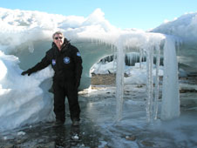
“Hoover has collected meteorites and microbial extremophiles from Antarctica; novel bacteria from the glaciers and permafrost of Antarctica, Patagonia, Siberia and Alaska, and from haloalkaline lakes, geysers and volcanoes of California, Alaska, Crete and Hawaii. He has discovered three new species of bacteria from Mono Lake in California -- Spirochaeta americana, Desulfonatronum thiodismutans and Tindallia californiensis -- and another, Carnobacterium pleistocenium, which survived for 32,000 years in a frozen Alaskan pond.” (Hoover)
Hoover at Schirmacher Oasis ice cave in Antarctica in February 2009. Image credit: NASA/MSFC
He has over 40 years of experience with working for NASA; in 2009 he submitted a paper to be peer revived by the academic community. He claimed that he had found proof that life was present on a meteor that he had collected. . “I have discovered evidence of microfossils similar to Cyanobacteria, in freshly fractured slices of the interior surfaces of the Alais, Ivuna, and Orgueil CI1 carbonaceous meteorites.” (Hoover)
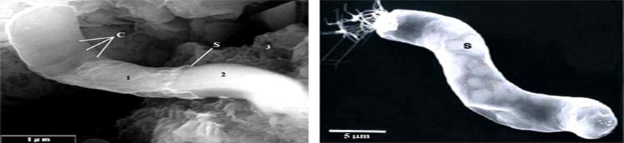
(Possible Alien Bacteria) (Earth Bacteria)
(Riccardo Guerrero / Richard B. Hoover / Journal of Cosmology)

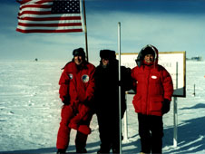
With the findings, of Hoover, not only can these little cyano survive the extremes of earth they now are Hoover believes traveling through space on meteors. Scientists recently proved that Hoover’s theory could be correct. “Microbes called cyanobacteria survived attached to the space station's exterior for 553 days”(Dou). Cyanobacteria can live off nutrients and also is photosynthetic which means using light to produce energy. This means it lived an inconceivable amount of time being exposed in space using sunlight to keep living. It made its way back on earth and was taken to a lab where it continued to spread and flourish. This bacteria surviving in space lead to a bunch of different questions and theory’s, if this bacteria could survive in space and Richard Hoover has potentially found these on meteors. Then it is possible that life got its start here on earth from a meteor crashing into earth and giving our planed the start of life that it needed. Cyano give off oxygen as a byproduct have given us our oxygen rich environment today. “The blue green cyanobacteria thrive in low oxygen conditions, this lead to the cyanobacteria being very efficient in expelling oxygen”(Moe 158). Hoover has possibly just found what made our earth oxygen rich today, and how it arrived on our planet.
Jim Lovell is on the left, and Owen Garriott on the right, joined Dr. Richard Hoover at the South Pole Image credit: NASA

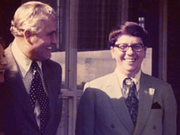
Hoover has done many great things in his lifetime. He has worked hard since the time that he was high school to get where he is now. Such an amazing career and he’s still at it working at NASA. With 250 papers that is a great career with just that. But he also has to his credit 33 volumes. And even has been NASA inventor of the year in 1992. 11 Patents on things he has invented is also very impressive. The most impressive thing to date in his career is the finding of the fossilized remains on ancient meteors. All his paper needs now is the scientific community to agree on his findings and it will change the history books forever. Hoover could be the one that has finally answered the question that I think everyone wonders if it’s actually possibly if life is living elsewhere in our universe. Richard Hoover has had an amazing career but I believe is greatest finding is just a peer review away. With the proof of his findings being correct history will be changed forever.
Richard Hoover on the right, with Wernher von Braun on Dec. 16, 1972, to witness the launch of Apollo 17
Image credit: NASA

Work Cited
Dou, Eva. "Microbial Star Trekkers Survive 553 Days in Space." . N.p., September 16, 2010. Web. 21 Sep 2012.
Moe, Martin. Marine Aquarium Handbook. Third Edition. Neptune City New Jersey: T.F.H. Publications Inc., 2009. 158. Print
Anderson, Janet. "NASA Marshall Center Astrobiologist Richard Hoover Awarded 2009 SPIE Gold Medal." . NASA, 5 2009. Web. 6 Nov 2012
Photograph’s/ Pictures
Guerrero, Riccardo, and Richard Hooveer. Fossils of Cyanobacteria in CI1 Carbonaceous Meteorites . 2011. Journal of CosmologyWeb. 17 Oct 2012.

